1)Autopay Enroll Error

2)Paypal after submitting UN and pwd shows Buffering even after 2 min

When tried 2nd time below error appears

3)For [christianmedina1974@gmail.com](mailto:christianmedina1974@gmail.com) changed username to cmedina1 but old username [christianmedina1974@gmail.com](mailto:christianmedina1974@gmail.com) is working for login

5)User-[tobyjamesw30@gmail.com](mailto:tobyjamesw30@gmail.com)

Clicking Renew now throws error

8)banderson06-Invalid data displayed in New Offer page

9)No email received by me after Sharing by using Mail App

10)Amount mismatch between Refer a friend and Rewards screen

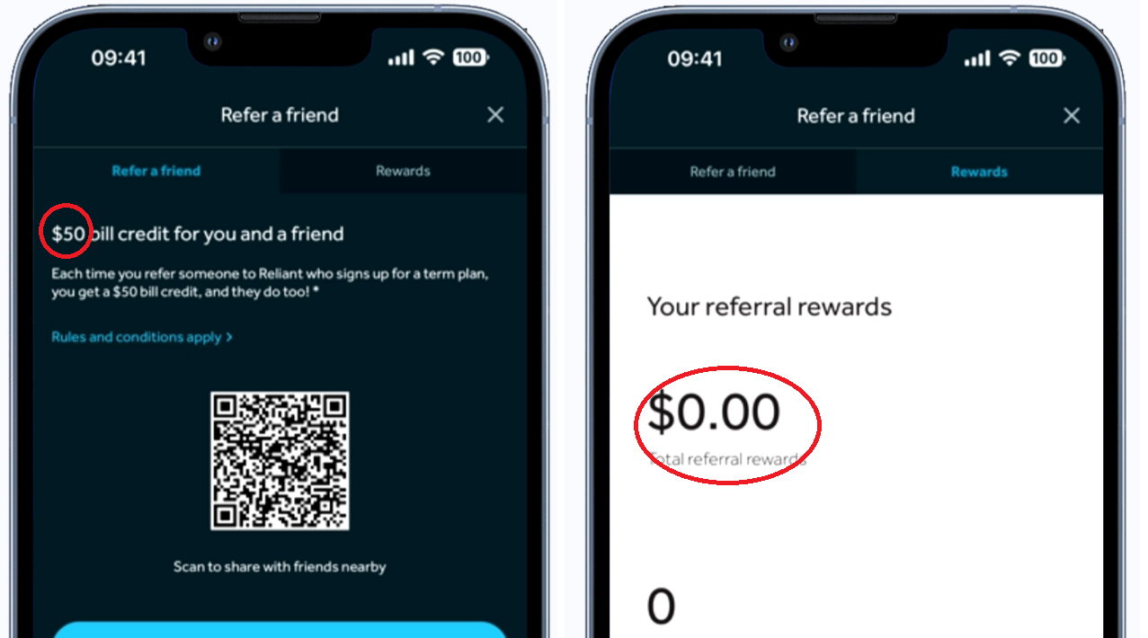

11)Move my service error

12)Move my Service when Business address is entered it doesn’t display message “Cannot move to Business Adress”

13)Feedback Promo button was displayed but not Feedback promo link after submitting Move my request